Cheatsheet: File Processing

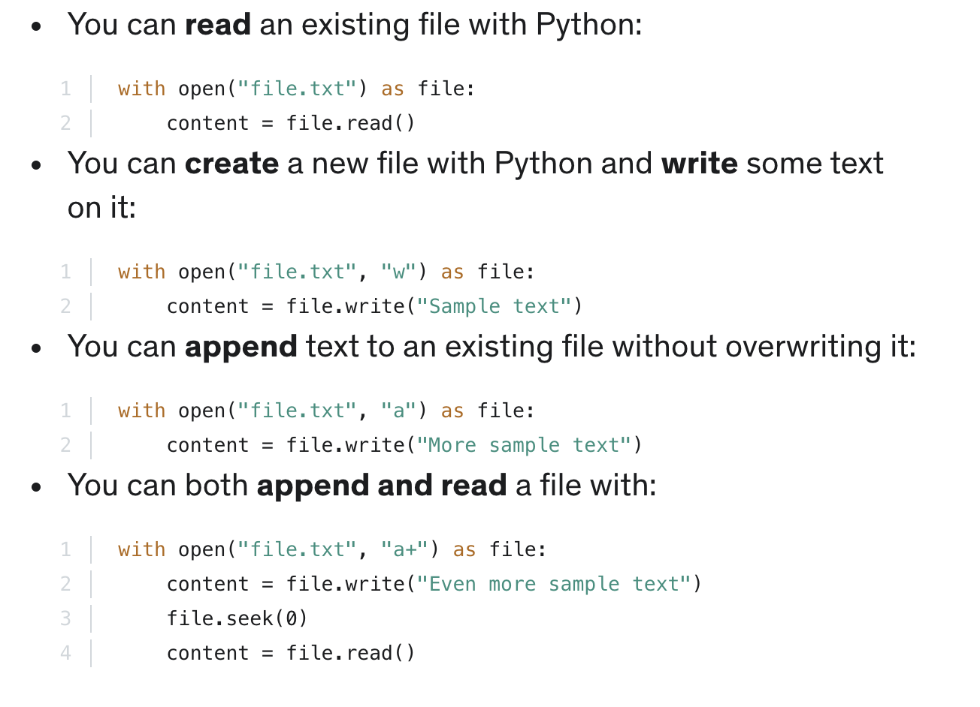
In this section, you learned that:

